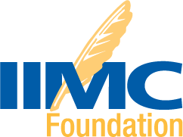
LITTLE ROCK CONFERENCE REGISTRATION PACKAGE AND 4-NIGHTS HOTEL
Planning on attending the Little Rock Conference? Why not have FREE registration and four nights hotel FREE? Thanks to the generous donation from IIMC, the IIMC Foundation is offering you an opportunity to win four nights lodging and one free Conference Registration Package for the upcoming conference in Little Rock, Arkansas, for May 22-25, 2022, valued at $1,600.
Purchase a chance online HERE or return the flyer below to the IIMC Foundation Treasurer, P. O. Box 333, Dysart, IA 52224.
Entries must be received by February 15, 2022!

CONFERENCE T-SHIRTS AVAILABLE
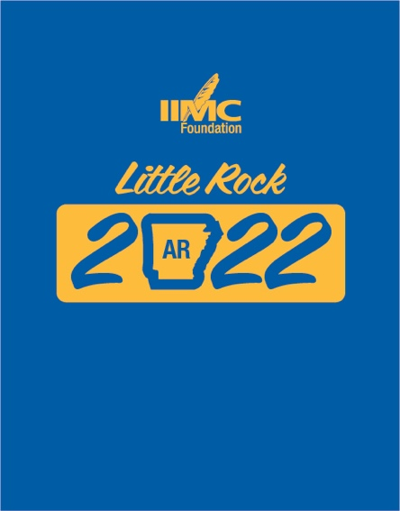
Click on the link below to purchase a commemorative T-shirt for the 2022 IIMC Annual Conference this May in Little Rock, AR! Your $25 donation will add to the fun and promote the conference while supporting the Foundation and municipal clerk education. Follow the easy instructions below to order yours for pickup at the conference.
- Click on link below
- Complete contact information
- Select "Drawings/Special Events"
- Select "Foundation T-Shirt"
- Enter number of T-shirts to purchase ($25 each)
- Select T-shirt size
- Click on "Proceed to Payment" to complete order
Thank you for supporting the Foundation and we look forward to seeing you in Little Rock!

PURCHASE T-SHIRT

A WEEK IN HAWAII
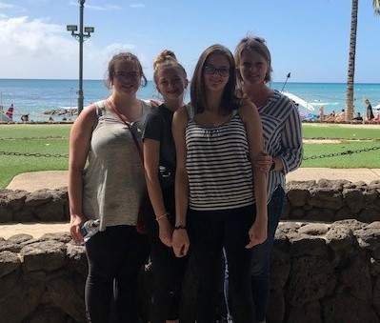
Sponsored by the IIMC Foundation and American Legal Publishing, this education fundraiser can land you in beautiful Hawaii! The 2022 winner will be selected at the annual conference in Little Rock, Arkansas, on May 25, 2022.
Week-long trip for two to Hawaii...Airfare and hotel included!
Tickets are available HERE or by completing the flyer.
2019 Winner, Dani Snyder, Fairbanks, AK
$20 each or 3 for $50, take a chance...or two or three!
It’s all for a good cause—furthering clerks’ education through scholarships and IIMC education programs – because all proceeds support the IIMC Foundation and IIMC education programs.

SILENT AUCTION – SHOPPING VIA APP

By popular demand, the silent auction scheduled for the IIMC Annual Conference in Little Rock this May will again be conduct via a mobile app. Auction items will be displayed at the conference. Whether at the conference or participating remotely, the fun interactive bidding aims to bolster funding for clerk education.
You can help by donating items and bidding!

Please contact the Foundation at iimcfoundation@iimc.com for more information on how to donate items or volunteer for this event in the future.

DONATE NOW…
Donate Any Amount
All donations are welcome - give what is comfortable for you.

IIMC Dues Renewal
Capture the easy opportunity to donate when renewing your IIMC membership. Add the donation amount on the dues renewal form.
Use a Donation Pledge Card
Make a tax-deductible contribution today by completing the pledge card posted below. You can also contribute by credit card. Pledges in U.S. Dollars can be paid monthly or at the end of the calendar year. IIMC Foundation's tax ID number is 95-3926604.

Memorial Gift
Remember a loved friend or family member with a Memorial donation in their honor and designate those to receive notice of your remembrance.

Planned Giving
Remember the municipal clerks profession by planning ahead. More information on this option is found here.

This is YOUR Foundation. Let’s make it stronger and do more.

